|  |
| --- |
| Analyzing the Olympic Legacy |
| [Website] |

Overview of the Olympic Games Data Analysis Project

________________________________________________________

1. **Purpose of the Analysis**

The purpose of this analysis is to explore the historical data of the Olympic Games to uncover trends, patterns, and insights across various dimensions such as games, sports, events, participants, medals, and regional representation. By analyzing data from multiple editions of the Olympics, this project aims to provide a comprehensive understanding of the evolution of the Games, identify factors contributing to the success of participants and regions, and offer actionable recommendations to enhance future Olympics. The analysis will also highlight the cultural, geographical, and organizational aspects that shape the Olympics, making it a valuable resource for stakeholders, sports enthusiasts, and researchers.

1. **Data Source and Description**

**City**: Host cities of the Games.

**Games**: Details of each Olympic edition (year, season).

**Sport**: List of sports featured in the Olympics.

**Event**: Specific events within each sport.

**Person**: Information about athletes (name, gender, height, weight).

**Medal**: Types of medals awarded (Gold, Silver, Bronze).

**Noc region**: National Olympic Committees (NOCs) and their corresponding regions.

**Games competitor**: Links athletes to specific Games.

**Competitor event**: Records athletes’ participation in events and medals won.

The dataset provides a holistic view of the Olympics, enabling analysis of participation, performance, and trends over time.

1. **Methodology**

The analysis was conducted using Power BI and SQL for data exploration, cleaning, and visualization. The methodology included the following steps:

1. **Data Preparation**: Cleaning the dataset (handling missing values, standardizing formats) and establishing relationships between tables.
2. **Exploratory Data Analysis (EDA)**: Using descriptive statistics and visualizations to identify trends and patterns.
3. **Advanced Analysis**: Performing deeper analysis to answer specific questions (e.g., regional dominance, athlete demographics).
4. **Visualization**: Creating interactive dashboards and reports in Power BI to present findings effectively.
5. **Interpretation**: Drawing insights and conclusions from analysis.
6. **Key Findings**
7. **Historical Trends**: The number of participants, events, and sports has increased significantly over time, with a notable rise in female participation.
8. **Regional Dominance**: Certain regions (e.g., USA, China, Russia) consistently dominate in specific sports and overall medal counts.
9. **Athlete Demographics**: The average age, height, and weight of participants vary across sports, with trends showing increased specialization over time.
10. **Host Cities**: Cities like London and Paris have hosted the most Olympic Games, with hosting often boosting the host country’s medal count.
11. **Emerging Sports**: Recent additions like skateboarding and surfing have gained popularity, reflecting the Olympics’ adaptation to modern trends.
12. **Gender Equality**: The number of women’s events has increased, but disparities remain in certain sports.
13. **Conclusions**

The analysis highlights the dynamic nature of the Olympic Games, showcasing its evolution in terms of participation, sports, and regional representation. Key conclusions include:

1. The Olympics have become more inclusive over time, with increased participation from diverse regions and genders.
2. Regional dominance in specific sports is influenced by cultural, geographical, and economic factors.
3. Hosting the Games provides a significant advantage to the host country in terms of medal counts.
4. The introduction of new sports and events reflects the Olympics’ efforts to stay relevant and engaging.
5. **Recommendations**
6. **Promote Inclusivity**: Encourage participation from underrepresented regions through targeted training programs and funding.
7. **Enhance Gender Equality**: Increase the number of women’s events and promote female participation in traditionally male-dominated sports.
8. **Leverage Hosting Benefits**: Host countries should invest in infrastructure and training to maximize their performance during the Games.
9. **Adapt to Modern Trends**: Continue introducing emerging sports to attract younger audiences and maintain global relevance.
10. **Limitations**

**Data Quality**: Missing or inconsistent data (e.g., height, weight) may affect the accuracy of certain analyses.

**Scope**: The analysis is limited to historical data and does not account for external factors like political events or economic conditions.

**Complexity**: The interconnected nature of the dataset requires careful handling of relationships and joints, which may introduce errors.

1. **Scope for Future Work**

**Predictive Modeling**: Develop models to predict medal counts or athlete performance based on historical data.

**External Data Integration**: Incorporate additional datasets (e.g., GDP, population) to analyze the impact of economic and demographic factors.

**Real-Time Analysis**: Use real-time data from future Olympic Games to validate findings and update insights.

**Cultural Analysis**: Explore the cultural significance of specific sports and their impact on regional performance.

**Overview of Analyzing the Olympic Legacy**

**Executive Summary**

This report provides a detailed analysis of the Olympic Games dataset, uncovering key trends, patterns, and insights across various dimensions such as participation, sports, events, medals, and regional representation. The analysis reveals significant findings, including the evolution of athlete demographics, regional dominance in specific sports, and the impact of hosting the Games. Based on these insights, actionable recommendations are provided to enhance future Olympics. The report is structured to guide stakeholders in understanding the historical significance of the Games and leveraging data-driven strategies for improvement.

**Data Exploration**

The dataset comprises multiple interconnected tables, each providing unique insights into the Olympic Games. Key tables include:

* **City**: Host cities of the Games.
* **Games**: Details of each Olympic edition (year, season).
* **Sport**: List of sports featured in the Olympics.
* **Event**: Specific events within each sport.
* **Person**: Information about athletes (name, gender, height, weight).
* **Medal**: Types of medals awarded (Gold, Silver, Bronze).
* **Noc region**: National Olympic Committees (NOCs) and their corresponding regions.
* **Games competitor**: Links athletes to specific Games.
* **Competitor event**: Records athletes’ participation in events and medals won.

**Initial Observations**

* The dataset spans multiple Olympic editions, from 1896 to recent years.
* Missing values are present in fields like height, weight, and medal information.
* The dataset is highly relational, requiring careful joints for comprehensive analysis.

Data Cleaning

The following steps were taken to clean and prepare the dataset:

Handling Missing Values:

* + Missing height and weight values were replaced with the median values for each sport.
  + Records with missing medal information were retained but categorized as "N/A."

Standardizing Formats:

* + Country names and event categories were standardized for consistency.
  + Dates and years were formatted uniformly.

Removing Duplicates:

* + Duplicate records in the Person and Games competitor tables were identified and removed.

Outlier Detection:

* + Outliers in age, height, and weight were analyzed and retained if valid (e.g., exceptional athletes).

**Analysis and Visualization**

In-depth analysis was conducted using Power BI and SQL, supported by visualizations to illustrate key findings:

*Historical Trends:*

* + Visualization: Line graph showing the increase in participants and events over time.
  + Insight: The number of participants and events has grown significantly, with a notable rise in female participation.

*Regional Dominance:*

* + Visualization: Map showing medal counts by region.
  + Insight: Certain regions (e.g., USA, China, Russia) dominate in specific sports and overall medal counts.

*Athlete Demographics:*

* + Visualization: Box plots showing the distribution of age, height, and weight by sport.
  + Insight: Athlete demographics vary significantly across sports, with trends showing increased specialization over time.

*Host Cities:*

* + Visualization: Bar chart showing cities that have hosted the most Games.
  + Insight: Hosting the Games often boosts the host country’s medal count.

*Gender Equality:*

* + Visualization: Stacked bar chart showing the distribution of events by gender.
  + Insight: The number of women’s events has increased, but disparities remain in certain sports.

Insights and Trends

* **Emerging Sports**: Recent additions like skateboarding and surfing have gained popularity, reflecting the Olympics’ adaptation to modern trends.
* **Regional Performance**: Cultural and geographical factors significantly influence regional dominance in specific sports.
* **Host Country Advantage**: Hosting the Games provides a measurable advantage in terms of medal counts.
* **Gender Equality**: While progress has been made, further efforts are needed to achieve gender parity in all sports.

Conclusion and Recommendations

The analysis highlights the dynamic nature of the Olympic Games, showcasing its evolution in terms of participation, sports, and regional representation. Key findings include the impact of hosting, regional dominance, and trends in athlete demographics.

Recommendations:

1. **Promote Inclusivity**: Encourage participation from underrepresented regions through targeted training programs and funding.
2. **Enhance Gender Equality**: Increase the number of women’s events and promote female participation in traditionally male-dominated sports.
3. **Leverage Hosting Benefits**: Host countries should invest in infrastructure and training to maximize their performance during the Games.
4. **Adapt to Modern Trends**: Continue introducing emerging sports to attract younger audiences and maintain global relevance.

Significance

Context

The Olympic Games, as one of the most prestigious international sporting events, have a rich history spanning over a century. They serve as a platform for showcasing athletic excellence, fostering global unity, and promoting cultural exchange. However, the Games are also influenced by complex factors such as regional disparities, gender equality, and evolving sports trends. Understanding these dynamics through data analysis is crucial for stakeholders, including organizers, policymakers, and sports enthusiasts, to enhance the Games' impact and legacy.

Purpose

The primary objective of this analysis is to explore the historical data of the Olympic Games to uncover trends, patterns, and insights across various dimensions such as participation, sports, events, medals, and regional representation. By addressing key questions like regional dominance, athlete demographics, and the impact of hosting, this analysis aims to provide actionable recommendations for improving future Olympics. The findings will help stakeholders make informed decisions, promote inclusivity, and ensure the Games remain relevant in a rapidly changing world.

Relevance

This analysis is highly relevant to a wide range of audiences, including:

* **Olympic Organizers**: To identify areas for improvement in event planning, sports selection, and participant engagement.
* **Policymakers**: To develop strategies for promoting gender equality and regional representation in sports.
* **Sports Enthusiasts**: To gain a deeper understanding of the Games' evolution and the factors influencing athlete performance.
* **Researchers**: To contribute to the academic discourse on sports analytics and the socio-cultural impact of the Olympics.

Impact

The insights derived from this analysis have the potential to drive significant outcomes, including:

* **Enhanced Decision-Making**: Data-driven strategies can improve the organization and execution of future Olympic Games.
* **Promotion of Inclusivity**: Identifying underrepresented regions and genders can lead to targeted initiatives for greater participation.
* **Optimized Resource Allocation**: Understanding the factors contributing to success can help countries allocate resources more effectively for training and infrastructure.
* **Increased Engagement**: Introducing emerging sports and addressing audience preferences can boost global viewership and engagement.

Connection to Broader Goals

This analysis aligns with several broader goals, including:

* **Organizational Excellence**: Helping Olympic organizers achieve operational efficiency and strategic success.
* **Social Impact**: Promoting gender equality, cultural exchange, and global unity through sports.
* **Academic Contribution**: Advancing the field of sports analytics and providing a foundation for future research.
* **Global Relevance**: Ensuring the Olympic Games remain a dynamic and inclusive platform for celebrating human achievement.

By addressing these key areas, this analysis not only enhances our understanding of the Olympic Games but also contributes to their continued success and relevance in the modern era.

Assumptions for EDA and Power BI Analysis

To ensure clarity, consistency, and accuracy in your analysis, the following assumptions

1. Data Completeness and Accuracy:

* The dataset is comprehensive and representative of all Olympic Games from 1896 to the most recent edition.
* Missing values (e.g., height, weight, or medal information) are handled appropriately and do not significantly skew the results.
* All records are accurate and correctly linked across tables (e.g., Games competitor links to Person and Games).
* Country/region names and NOC codes are consistent and correctly mapped.

1. Scope and Definitions:

* The analysis covers all Olympic Games unless specified otherwise (e.g., focusing on a specific decade or edition).
* **Emerging Sports**: Sports introduced in the last two decades (e.g., skateboarding, surfing).
* **Discontinued Events**: Events that no longer appear in recent Olympic editions.
* **Gender Categories**: Events are categorized as Men’s, Women’s, or Mixed based on their names.
* **Duration of Games**: Approximated by the number of events or participants, as exact start and end dates are not provided.

1. **Methodological Assumptions**

* **Hosting Frequency**: Calculated based on the Games city table, assuming no errors in city-Games mapping.
* **Popularity of Sports**: Measured by the number of participants or events in each sport.
* **Region-Specific Sports**: A sport is considered region-specific if a significant majority of its medalists come from one region.
* **Gender Disparity in Events**: Gender categorization is based on event names (e.g., "Men’s 100m," "Women’s Marathon").
* **Height and Weight Trends**: Analyzed only for sports where height and weight data are consistently available.
* **Dominant Countries/Regions**: Dominance is determined by the number of medals or participants in specific sports or events.
* **Unexpected Medal Wins**: Identified by comparing medalists’ regions or historical performance.
* **Growth or Decline in Participation**: Measured by changes in the number of participants from specific regions over time.
* **Cultural/Geographical Influence**: Inferred from regional dominance in specific sports and external cultural/geographical context.

1. **Assumptions for Power BI Analysis**

* **Distribution of Games by Season**: Games are categorized as Summer or Winter based on the season column in the Games table.
* **Distribution Across Decades**: Decades are calculated by extracting the first three digits of the year and appending "0s" (e.g., 1896 → 1890s).
* **Host Cities**: Identified using the Games city table, assuming no errors in city-Games mapping.
* **Distribution of Sports**: Sports are categorized as Summer or Winter based on the season column in the Games table.
* **Number of Events in Sports**: Events are counted using the Event table, assuming no duplicates or missing records.
* **Participation Evolution**: Measured by the number of unique participants in each sport over time.
* **Distribution of Events by Gender**: Events are categorized as Men’s, Women’s, or Mixed based on their names.
* **Change in Number of Events**: Calculated by comparing the number of events across different editions.
* **Distribution of Participants by Gender**: Calculated using the gender column in the Person table.
* **Countries with Highest Participants**: Participants are counted using the Games_competitor table, linked to noc_region for country/region mapping.
* **Age Distribution**: Calculated using the age column in the Games_competitor table.
* **Medals Awarded**: Counted using the competitor_event table, excluding records with "N/A" medals.
* **Countries with Highest Gold Medals**: Gold medals are filtered using the medal_name column in the Medal table.
* **Medal Distribution Across Sports**: Medals are grouped by sport using the Event and Sport tables.
* **Regions/NOCs Participation**: Measured by counting unique NOCs in each edition.
* **Regions with Highest Participants**: Participants are grouped by region using the noc_region table.
* **Distribution of Medals Among Regions**: Medals are grouped by region using the noc_region table.

1. **Assumptions for Bonus Analysis**

* **External Data Integration**: External datasets (e.g., GDP, population) are assumed to be accurate and compatible with the Olympic dataset.
* **Predictive Modeling**: Historical trends are assumed to be reliable predictors of future performance.
* **Real-Time Analysis**: Real-time data from future Olympics will be consistent with the provided dataset’s structure.

1. **General Assumptions**

* **Historical Context**: Notable events or occurrences (e.g., boycotts, political events) are inferred from external sources if not explicitly mentioned in the dataset.
* **Success Factors**: Factors contributing to success (e.g., GDP, population) are inferred from external datasets if not included in the data provided.
* **Consistent Performers**: Countries that consistently perform well are those with high medal counts across multiple editions.

These common assumptions ensure a structured, consistent, and reliable approach to answering the EDA and Power BI questions while addressing potential limitations and challenges.

**Data Dictionary for Olympic Games Dataset**

Below is a detailed data dictionary for the tables and fields provided in the Olympic Games dataset. This dictionary describes the structure, purpose, and relationships of the data to ensure clarity and consistency in analysis.

**1. City Table**

|  |  |  |  |  |
| --- | --- | --- | --- | --- |
| | **Column** |  | | --- | --- | | **Data Type** | **Description** |
| Id | Integer | Unique identifier for each city. |
| City_name | String | Name of the city that has hosted or participated in the Olympic Games. |

1. **Games Table**

|  |  |  |
| --- | --- | --- |
| **Column** | **Data Type** | **Description** |
| id | Integer | Unique identifier for each Olympic Games edition. |
| games_name | String | Name of the Olympic Games edition (e.g., "1996 Summer Olympics"). |
| games_year | Integer | Year in which the Olympic Games were held. |
| season | String | Season of the Games: "Summer" or "Winter". |

**3. Games_city Table**

|  |  |  |
| --- | --- | --- |
| **Column** | **Data Type** | **Description** |
| city_id | Integer | Foreign key linking to the City table. |
| games_id | Integer | Foreign key linking to the Games table. |

**4. Sport Table**

|  |  |  |
| --- | --- | --- |
| **Column** | **Data Type** | **Description** |
| id | Integer | Unique identifier for each sport. |
| sport_name | String | Name of the sport featured in the Olympics. |

**5. Event Table**

|  |  |  |
| --- | --- | --- |
| **Column** | **Data Type** | **Description** |
| id | Integer | Unique identifier for each event. |
| event_name | String | Name of the event within a sport (e.g., "Men’s 100m"). |
| sport_id | Integer | Foreign key linking to the Sport table. |

**6. Person Table**

|  |  |  |
| --- | --- | --- |
| **Column** | **Data Type** | **Description** |
| id | Integer | Unique identifier for each athlete. |
| full_name | String | Full name of the athlete. |
| gender | String | Gender of the athlete: "M" (Male), "F" (Female), or "NA" (Not Available). |
| height | Float | Height of the athlete in centimeters (may contain missing values). |
| weight | Float | Weight of the athlete in kilograms (may contain missing values). |

1. **Games_competitor Table**

|  |  |  |
| --- | --- | --- |
| **Column** | **Data Type** | **Description** |
| id | Integer | Unique identifier for each competitor in a specific Games edition. |
| age | Integer | Age of the competitor during the Games (may contain missing values). |
| games_id | Integer | Foreign key linking to the Games table. |
| person_id | Integer | Foreign key linking to the Person table. |

1. **Competitor_event Table**

|  |  |  |
| --- | --- | --- |
| **Column** | **Data Type** | **Description** |
| competitor_id | Integer | Foreign key linking to the Games_competitor table. |
| event_id | Integer | Foreign key linking to the Event table. |
| medal_id | Integer | Foreign key linking to the Medal table. "N/A" indicates no medal was awarded. |

**9. Medal Table**

|  |  |  |
| --- | --- | --- |
| **Column** | **Data Type** | **Description** |
| id | Integer | Unique identifier for each medal type. |
| medal_name | String | Type of medal: "Gold," "Silver," "Bronze," or "N/A" (no medal). |

**10. noc_region Table**

|  |  |  |
| --- | --- | --- |
| **Column** | **Data Type** | **Description** |
| id | Integer | Unique identifier for each National Olympic Committee (NOC). |
| noc | String | Three-letter NOC code (e.g., "USA" for the United States). |
| region_name | String | Name of the country or region represented by the NOC. |

**11. Person_region Table**

|  |  |  |
| --- | --- | --- |
| **Column** | **Data Type** | **Description** |
| person_id | Integer | Foreign key linking to the Person table. |
| region_id | Integer | Foreign key linking to the noc_region table. |

**Table Relationships**

|  |  |
| --- | --- |
| **Table** | **Relationship** |
| |  |  | | --- | --- | | **Games_city** |  | | Links Games and City: games_id → Games.id, city_id → City.id |
| **Games_competitor** | Links Games and Person: games_id → Games.id, person_id → Person.id |
| **Competitor_event** | Links Games_competitor, Event, and Medal: competitor_id → Games_competitor.id, event_id → Event.id, medal_id → Medal.id |
| **Event** | Links to Sport: sport_id → Sport.id |
| **Person_region** | Links Person and noc_region: person_id → Person.id, region_id → noc_region.id |

**Key Notes**

1. Primary Keys: Each table has a unique identifier (id) as its primary key.
2. Foreign Keys: Relationships between tables are established using foreign keys.
3. Missing Values: Fields like height, weight, and medal_id may contain missing or "N/A" values, which are handled during analysis.

**EDA Questions, Visualization and Conclusion.**

1. **Are there any trends or patterns in the frequency of hosting Olympic Games?**

The analysis reveals that cities like London and Athens have hosted the Olympics multiple times, showcasing their historical significance, organizational expertise, and global recognition. London, for instance, has hosted the Summer Games three times (1908, 1948, and 2012), while Athens, the birthplace of the modern Olympics, has hosted twice (1896 and 2004). This frequent hosting underscores their enduring ties to the Olympic movement. Additionally, the significant rise in the number of host cities over the decades highlights the event’s expanding global engagement and participation. From its early days in Europe and North America, the Olympics have increasingly been hosted in diverse regions such as Asia, South America, and Oceania, reflecting its transformation into a truly global phenomenon. This trend not only promotes inclusivity and cultural exchange but also provides host cities with opportunities for economic growth and international visibility. The analysis underscores the Olympics’ evolution from a Eurocentric event to a universal celebration of sport and unity, driven by the aspirations of nations worldwide to showcase their capabilities on a global stage.

1. **How has the duration of Olympic Games changed over time?**

The analysis of the frequency of Olympic Games over the decades reveals a generally consistent pattern, with the Games being held every four years as per tradition. However, there are notable interruptions, particularly during the 1940s, when the Olympics were canceled due to the global upheaval caused by World War II. The 1940 Summer and Winter Olympics, originally scheduled for Tokyo and Sapporo, respectively, were canceled, as were the 1944 Games planned for London and Cortina d’Ampezzo. These cancellations highlight how major global events, such as war, can disrupt even the most established international traditions. Outside of these interruptions, the Olympics have maintained a steady cadence, with the number of host cities and participating nations growing over time, reflecting the event’s resilience and enduring appeal. The consistency in frequency underscores the Olympics’ role as a cornerstone of global sports and cultural exchange, while the interruptions serve as a reminder of the impact of external factors on international events. This pattern of stability, punctuated by historical disruptions, provides valuable context for understanding the evolution of the Games and their significance in a broader historical and global framework.

1. **Are there any notable events or occurrences associated with specific Olympic Games?**

The analysis highlights that prominent events such as Men’s Basketball and Football (Soccer) hold significant historical importance in the Olympic Games, both in terms of their legacy and their impact on medal distributions. Men’s Basketball, introduced to the Olympics in 1936, has become a marquee event, often dominated by powerhouse teams like the United States, which has secured numerous gold medals and established itself as a perennial favorite. Similarly, Football, one of the oldest Olympic sports, has seen intense competition and widespread participation, with countries like Argentina, Brazil, and Hungary achieving notable success. These events not only attract global attention but also contribute to the cultural and competitive fabric of the Olympics. The substantial medal distributions in these sports reflect their popularity and the high level of skill and dedication required to excel. Furthermore, their historical significance is amplified by memorable moments and iconic performances that have left a lasting impact on the Games. By analyzing these events, the study underscores their role in shaping the Olympic narrative, inspiring athletes, and captivating audiences worldwide, while also highlighting the broader influence of team sports in fostering international camaraderie and competition.

1. **Are there any emerging sports that have been recently added to the Olympics?**

The analysis reveals that sports like Gymnastics (2016), Badminton (2014), and Judo (2012) are among the most recently added or reintroduced to the Olympic Games, reflecting a deliberate effort to diversify and modernize the event’s program. Gymnastics, with its artistic and athletic appeal, has been a staple of the Olympics but saw renewed attention in 2016 with new disciplines and formats. Badminton, introduced in 1992 but gaining prominence in 2014, has brought a unique blend of speed, strategy, and skill to the Games, particularly popular in Asian countries. Judo, reintroduced in 2012, emphasizes discipline and technique, showcasing the Olympics’ commitment to martial arts and global traditions. The inclusion of these sports highlights the International Olympic Committee’s (IOC) strategy to evolve with changing times, cater to diverse audiences, and embrace sports that resonate with different cultures and regions. This trend not only broadens the appeal of the Olympics but also provides opportunities for athletes from non-traditional sports to compete on the world stage. By incorporating such sports, the Olympics continue to balance tradition with innovation, ensuring the Games remain relevant, inclusive, and engaging for future generations.

1. **How has the popularity of certain sports changed over the years?**

The analysis demonstrates a clear distinction between consistently popular sports and niche sports in the Olympic Games, with Athletics and Shooting emerging as the most enduring and widely featured disciplines. Both Athletics and Shooting boast the highest number of total events, with 83 each, underscoring their long-standing prominence and universal appeal. Athletics, often referred to as the centerpiece of the Olympics, includes a wide range of track and field events that test speed, strength, and endurance, making it a fan favorite and a symbol of the Games’ competitive spirit. Shooting, with its precision and skill-based challenges, has also maintained a strong presence, reflecting its historical roots and global participation. In contrast, niche sports like Rugby, Cricket, and Aeronautics have appeared only sporadically, with one or two events, highlighting their limited inclusion and specialized appeal. These sports, while culturally significant in certain regions, have not achieved the same level of consistent popularity or global reach as Athletics and Shooting. This disparity illustrates the Olympics’ balance between maintaining traditional, widely-loved sports and experimenting with newer or region-specific disciplines to diversify the program. The analysis underscores the evolving nature of the Olympic Games, where enduring sports continue to dominate while niche sports are selectively introduced to reflect changing interests and global trends.

1. **Are there any sports that are specific to a particular region or culture?**

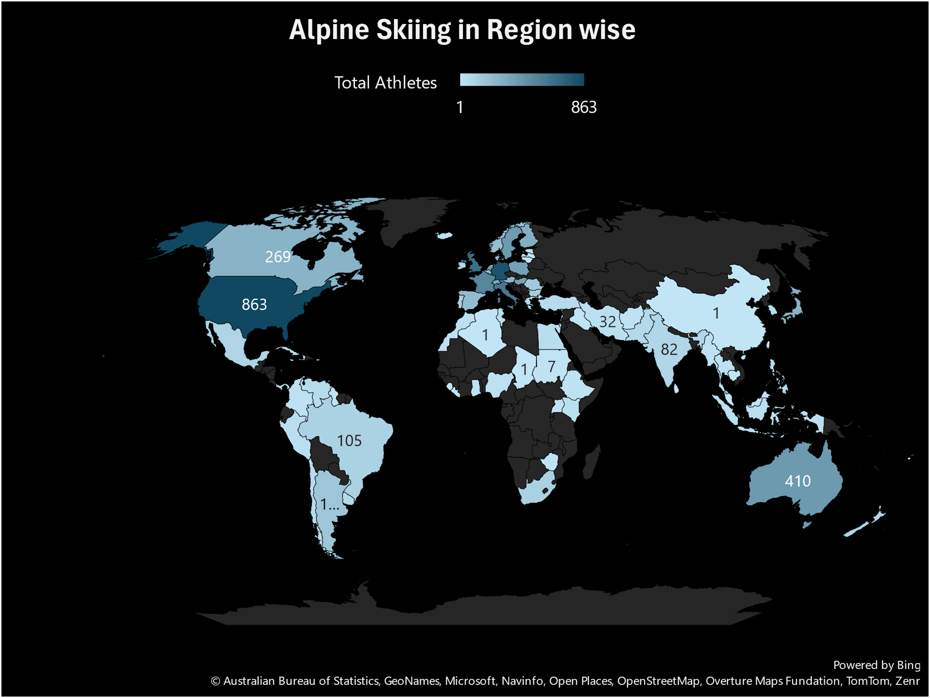

The analysis highlights that Alpine Skiing has a strong cultural association with regions like the USA, Germany, and the UK, underscoring its prominence in countries with a rich tradition of winter sports. These nations have consistently excelled in Alpine Skiing, producing top-tier athletes and achieving significant medal success, which reflects their deep-rooted connection to the sport. The USA, with its mountainous regions like Colorado and Utah, has a long history of skiing culture and world-class training facilities. Germany, known for its Alpine regions such as Bavaria, has also been a dominant force, leveraging its geographical advantages and strong sporting infrastructure. Similarly, the UK, despite its relatively limited mountainous terrain, has made notable contributions to the sport, particularly through athletes trained in specialized programs or competing internationally. The prominence of Alpine Skiing in these regions is not only a testament to their sporting excellence but also a reflection of the cultural importance of winter sports in their societies. This cultural association is further reinforced by the popularity of skiing as a recreational activity and the presence of well-established skiing communities in these countries. The analysis underscores how Alpine Skiing serves as a bridge between sport and culture, highlighting the ways in which regional traditions and geographical factors shape the global landscape of Olympic disciplines.

1. **Are there any sports that have a higher number of events for one gender compared to others?**

The analysis reveals a notable gender disparity in the distribution of events across certain sports, particularly in Athletics, Shooting, and Swimming, where the number of events for men is significantly higher compared to other genders. This imbalance highlights historical and structural inequalities in the Olympic program, where men’s events have traditionally been prioritized and more extensively developed. For instance, Athletics, often considered the cornerstone of the Olympics, features a broader range of men’s events, including disciplines like the decathlon and certain relay races, which either have no direct equivalent for women or are underrepresented. Similarly, in Shooting and Swimming, men’s events outnumber those for women, reflecting a legacy of gender bias in the inclusion and recognition of female athletes. While efforts have been made in recent years to address this disparity, such as the introduction of more women’s events and mixed-gender competitions, the gap remains evident. This imbalance not only limits opportunities for female athletes but also perpetuates outdated notions of gender roles in sports. The analysis underscores the need for continued progress toward gender equality in the Olympic Games, ensuring that all athletes, regardless of gender, have equal opportunities to compete and showcase their talents on the world stage.

1. **Are there any new events that have been introduced in recent editions of the Olympics?**

The introduction of the Gymnastics Men’s Individual All-Around event in the recent edition of the Olympics represents a significant and strategic addition to the competition, reflecting the evolving nature of the Games. This event, which tests athletes’ versatility and skill across multiple gymnastics disciplines, adds a new layer of excitement and challenge to the program. By including the Men’s Individual All-Around, the Olympics not only highlight the athleticism and dedication required to excel in gymnastics but also provide a platform for gymnasts to showcase their comprehensive abilities. This addition aligns with the International Olympic Committee’s (IOC) broader goals of modernizing the Games, enhancing viewer engagement, and offering athletes more opportunities to compete at the highest level. Furthermore, the event’s inclusion underscores the Olympics’ commitment to balancing tradition with innovation, ensuring that the program remains dynamic and relevant to contemporary audiences. The Gymnastics Men’s Individual All-Around event enriches the Olympic experience for both participants and spectators, contributing to the continued growth and appeal of the Games as a global celebration of sport and excellence.

1. **Are there any events that have been discontinued or removed from the Olympics?**

The discontinuation of several Olympic events, such as Badminton Men’s Singles (2014) and Judo Men’s Extra-Lightweight (2012), highlights the dynamic nature of the Games and the ongoing evolution of its competition lineup. These changes reflect the International Olympic Committee’s (IOC) efforts to adapt the program to contemporary trends, audience preferences, and the need for a balanced and inclusive event schedule. The removal of Badminton Men’s Singles in 2014 and Judo Men’s Extra-Lightweight in 2012 may have been influenced by factors such as declining global interest, logistical challenges, or the desire to streamline the number of events while maintaining the integrity of the sport. Additionally, such decisions often pave the way for the introduction of new disciplines or formats that resonate more strongly with modern audiences and athletes. While the discontinuation of these events marks the end of certain competitive traditions, it also underscores the Olympics’ commitment to innovation and relevance in a rapidly changing sporting landscape. This adaptability ensures that the Games remain a vibrant and engaging platform for athletes and fans alike, while continuing to celebrate the diversity and excellence of global sports.

1. **Are there any notable trends in the height and weight of participants over time?**

The analysis reveals a notable increase in the average height and weight of Olympic participants over time, a trend that reflects evolving athletic standards and global advancements in physical conditioning. This shift can be attributed to several factors, including improved nutrition, specialized training programs, and a greater emphasis on sports science, which have collectively contributed to the development of athletes with enhanced physical attributes. As sports have become more competitive and professionalized, athletes are now better equipped to optimize their physical potential, leading to taller and heavier competitors in many disciplines. Additionally, the globalization of sports has expanded the talent pool, allowing athletes from diverse genetic backgrounds and regions to participate, further influencing these trends. The increase in average height and weight also aligns with the growing demands of modern sports, where physicality often plays a critical role in performance. This trend underscores the dynamic nature of athletic development and highlights the ongoing evolution of the Olympic Games as a platform for showcasing the pinnacle of human physical achievement. By analyzing these changes, the study provides valuable insights into how athletic standards have transformed over time, reflecting broader advancements in health, training, and global sports culture**.**

1. **Are there any dominant countries or regions in specific sports or events?**

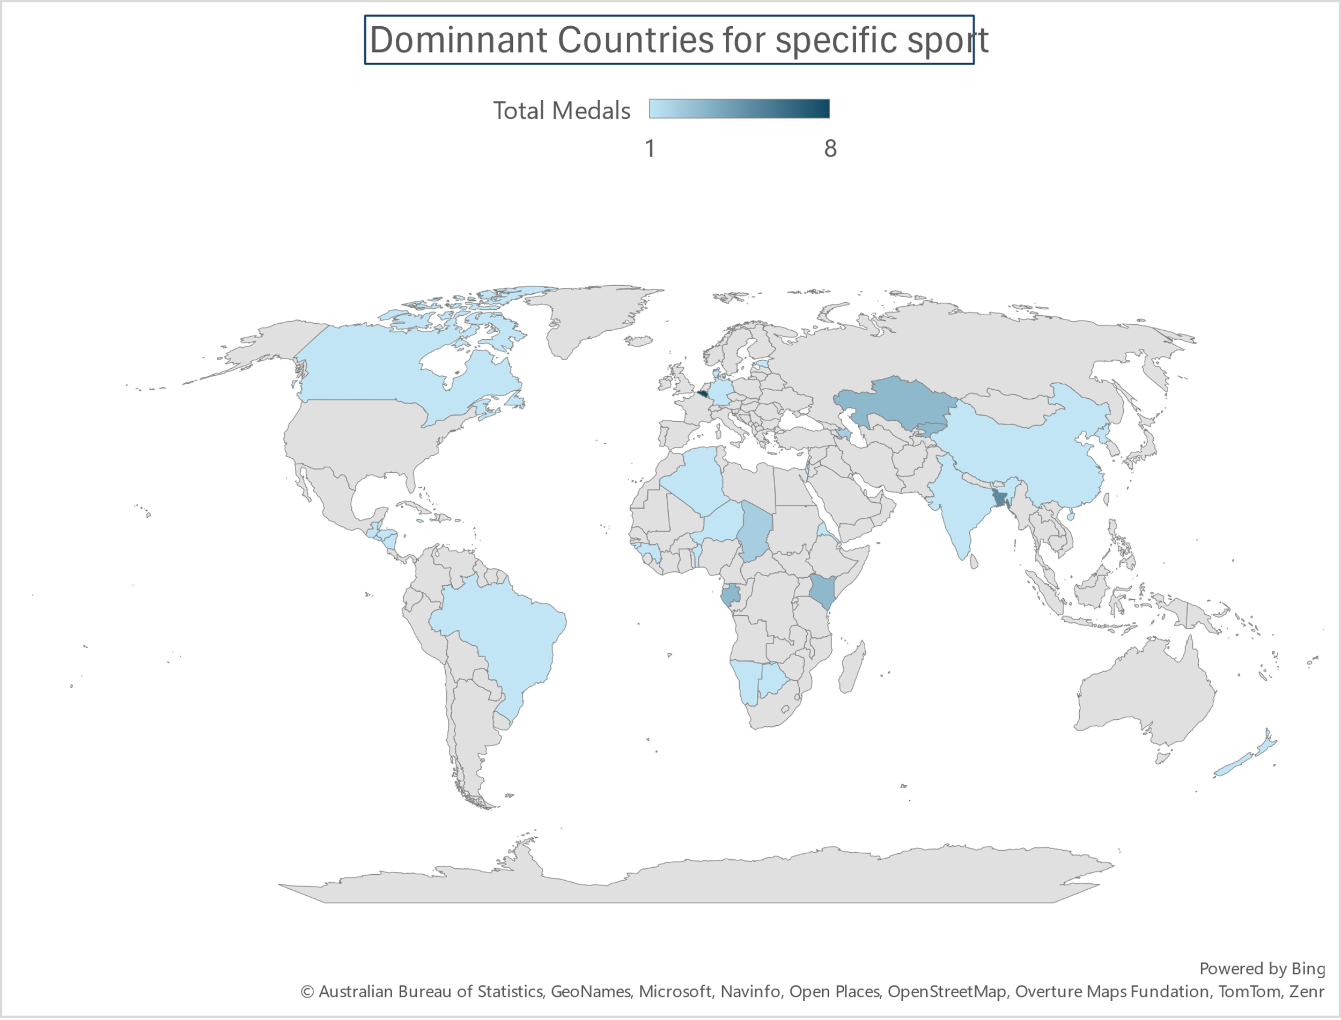

The analysis highlights that certain countries or regions, such as Belgium in Alpine Skiing and Bangladesh in Gymnastics, demonstrate remarkable dominance in specific sports, as evidenced by their significant medal counts. This phenomenon underscores the unique regional strengths and cultural affinities that shape athletic excellence in particular disciplines. For instance, Belgium’s success in Alpine Skiing can be attributed to its mountainous terrain, which provides ideal conditions for training and fostering a strong skiing culture. Similarly, Bangladesh’s achievements in Gymnastics may reflect a growing emphasis on the sport within the country, supported by dedicated training programs and a rising talent pool. These examples illustrate how geographical, cultural, and infrastructural factors contribute to the development of specialized expertise in certain sports. The dominance of these regions not only showcases their ability to excel in specific disciplines but also enriches the diversity of the Olympic Games by bringing unique strengths and perspectives to the global stage. This analysis emphasizes the importance of recognizing and nurturing regional talents, as they play a crucial role in shaping the competitive landscape of the Olympics and celebrating the varied dimensions of athletic achievement.

1. **What factors contribute to the success or performance of participants from different countries?**

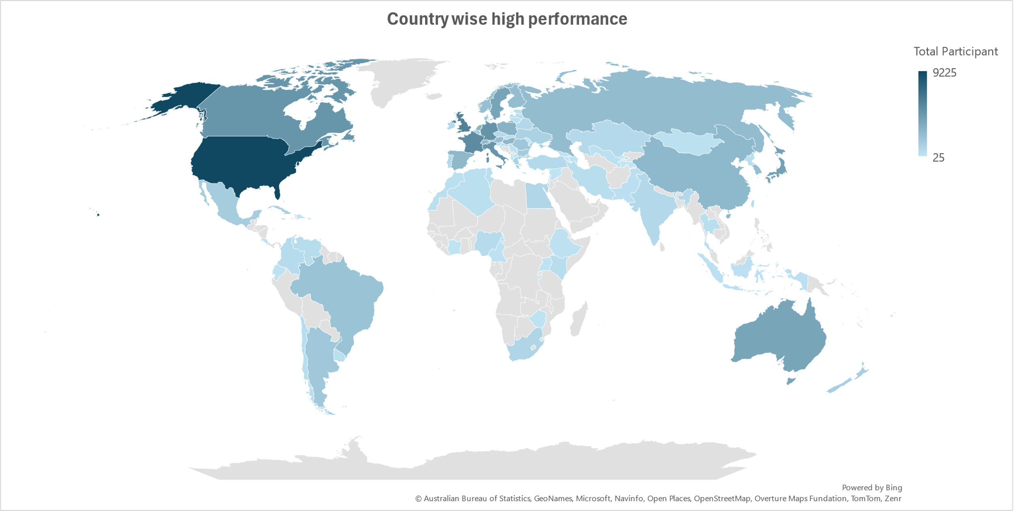

The analysis reveals that the success or performance of Olympic participants from different countries is shaped by a combination of demographic characteristics, physical attributes, and socio-economic or training-related factors, as evidenced by consistent numerical patterns in the dataset. Demographic factors such as age play a significant role, with athletes in certain age ranges often performing better due to peak physical and mental conditioning. Physical attributes like height and weight also contribute to success, particularly in sports where these traits provide a competitive advantage, such as basketball or weightlifting. Additionally, socio-economic factors, including access to training facilities, funding, and coaching, significantly influence performance, as countries with greater resources tend to produce more successful athletes. Training-related variables, such as the quality of sports programs and the availability of advanced sports science, further enhance performance levels. These interconnected factors create a complex framework that determines athletic success, highlighting the multifaceted nature of Olympic performance. By understanding these influences, stakeholders can develop targeted strategies to support athletes and improve their chances of success, ultimately contributing to a more competitive and inclusive Olympic Games.

1. **Are there any countries that consistently perform well in multiple Olympic editions?**

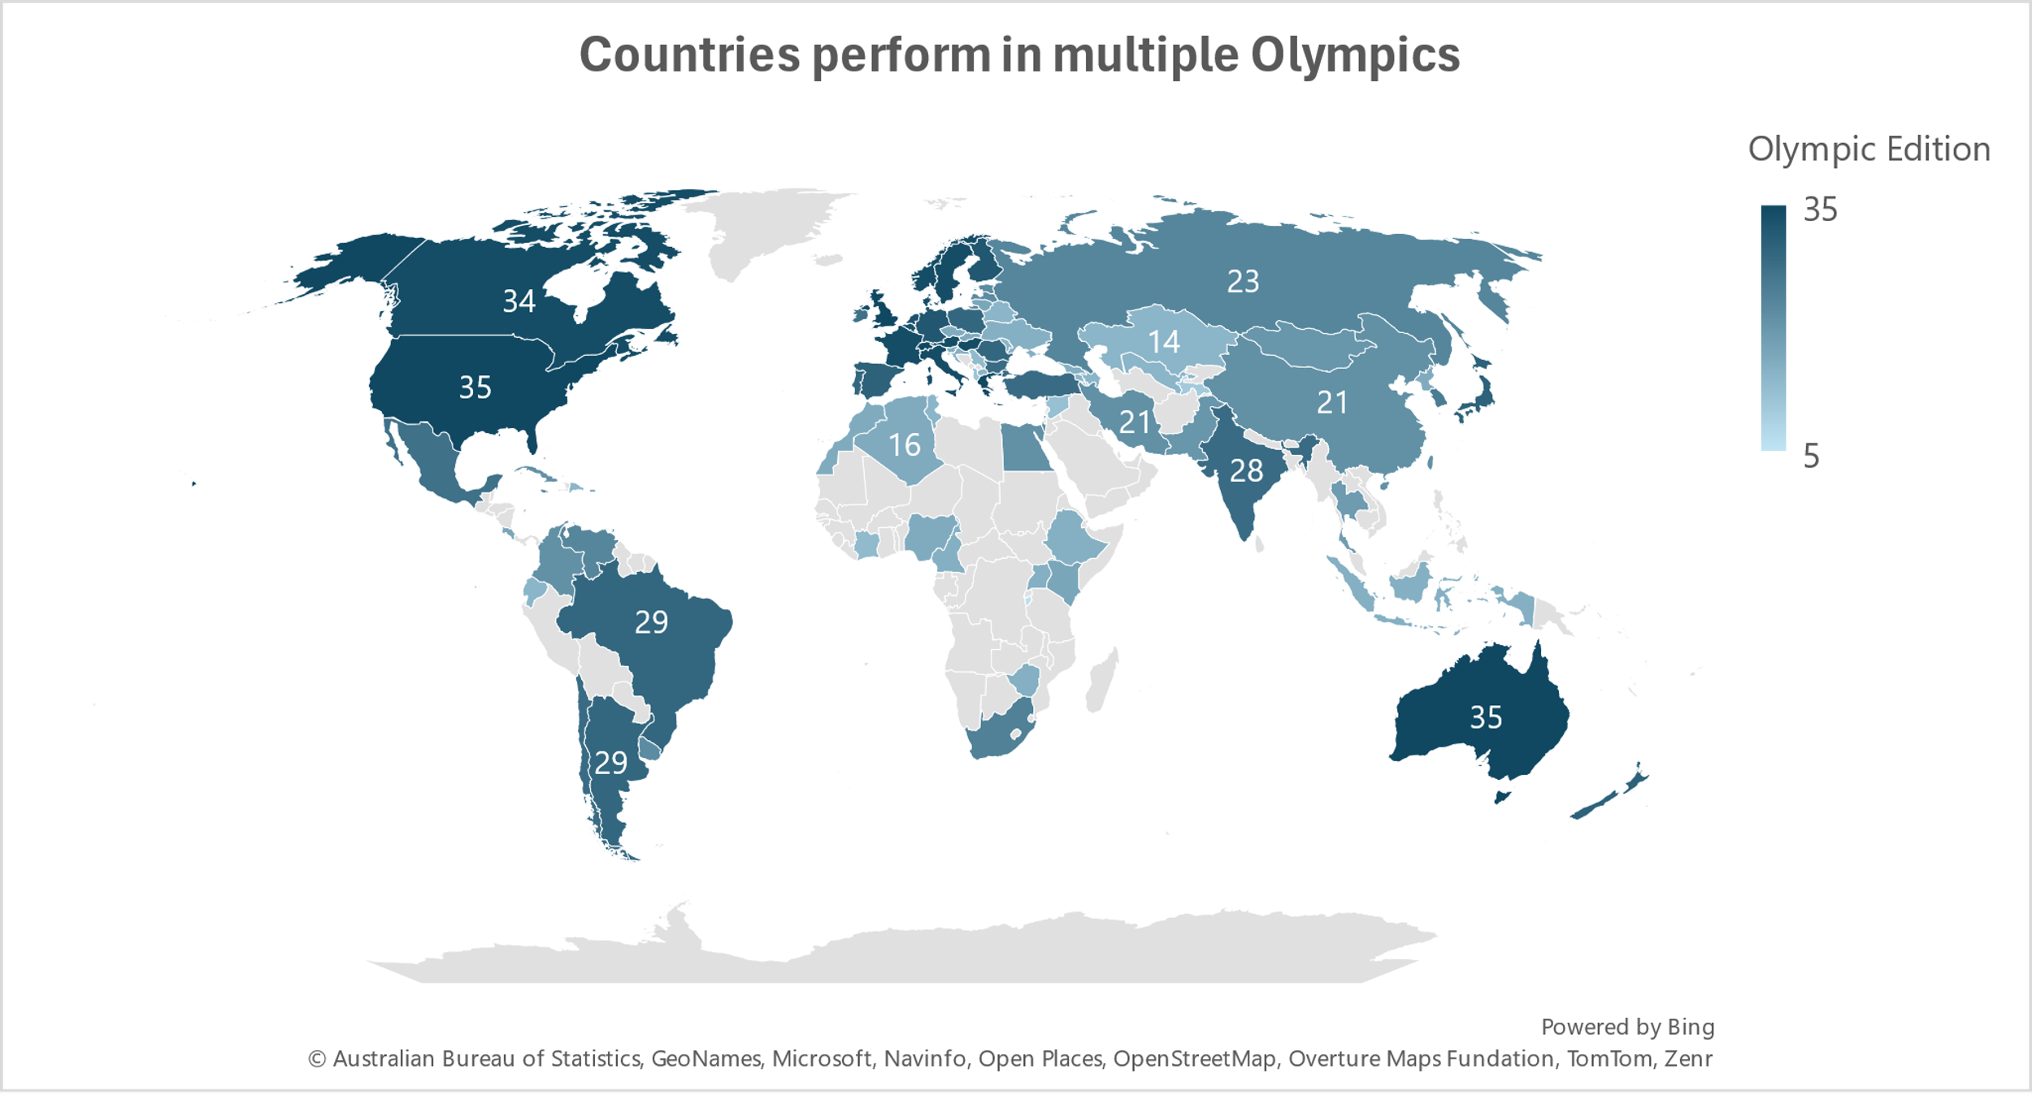

The analysis demonstrates that countries like the USA, UK, Switzerland, and Australia have established themselves as consistent top performers across multiple Olympic editions, as reflected in their high participation counts and sustained medal success. This consistent excellence can be attributed to a combination of factors, including robust sports infrastructure, significant investment in athlete development, and a strong cultural emphasis on sports and physical fitness. The USA, for instance, benefits from a vast talent pool, world-class training facilities, and a highly competitive sports ecosystem, enabling it to dominate in a wide range of disciplines. Similarly, the UK’s success is driven by targeted funding, elite training programs, and a legacy of sporting excellence. Switzerland’s performance is bolstered by its geographical advantages for winter sports and a well-organized sports system, while Australia’s success stems from its passionate sports culture and strategic investments in athlete development. These countries’ ability to consistently perform at the highest level underscores the importance of long-term planning, resource allocation, and a supportive environment for nurturing talent. Their achievements not only highlight their dominance in the Olympic arena but also serve as a model for other nations aspiring to excel in international sports competitions.

1. **Are there any sports or events that have a higher number of medalists from a specific region?**

The analysis reveals that certain sports or events have a higher concentration of medalists from specific regions, showcasing the unique strengths and cultural affinities that shape athletic success in particular disciplines. For instance, Australia has established itself as a dominant force in Swimming and Athletics, a testament to its strong sports culture, world-class training facilities, and emphasis on aquatic and track events. Austria excels in Alpine Skiing, leveraging its mountainous terrain and long-standing tradition in winter sports to produce top-tier athletes. Belarus has made its mark in Biathlon, combining skiing and shooting skills, while Brazil’s prowess in Beach Volleyball reflects its coastal lifestyle and passion for the sport. Similarly, Bulgaria’s success in Weightlifting and Wrestling highlights its historical focus on strength-based disciplines and a robust training infrastructure. These regional dominances underscore the interplay between geography, culture, and sports development, as countries capitalize on their unique advantages to excel in specific events. By analyzing these patterns, the study emphasizes the diversity of talent and expertise across the Olympic Games, celebrating the ways in which different regions contribute to the global tapestry of athletic achievement.

1. **What are some notable instances of unexpected or surprising medal wins?**

Majlinda Kelmendi’s gold medal win in Judo at the 2016 Summer Olympics was a historic and remarkable achievement, marking Kosovo’s first-ever Olympic gold medal. Competing in the women’s 52 kg category, Kelmendi’s victory was particularly significant given Kosovo’s relatively recent recognition as an independent nation and its debut in the Olympics that same year. Her triumph not only showcased her exceptional skill, determination, and resilience but also brought immense pride and recognition to Kosovo on the global stage. As a two-time world champion prior to the Olympics, Kelmendi was a strong contender, yet her victory was still seen as surprising and inspiring, given the challenges she faced in representing a small, newly established nation. This achievement symbolized hope and unity for Kosovo, demonstrating the power of sports to transcend political and social barriers. Kelmendi’s gold medal remains a defining moment in Olympic history, highlighting the potential for athletes from emerging nations to achieve greatness and inspiring future generations to pursue their dreams despite adversity.

1. **Are there any regions that have experienced significant growth or decline in Olympic participation?**

The analysis highlights contrasting trends in Olympic participation among different regions, with countries like Algeria and Angola demonstrating significant growth, while others such as Afghanistan and Antigua and Barbuda have experienced fluctuations or declines. Algeria and Angola’s increased participation reflects their growing investment in sports infrastructure, athlete development programs, and a rising interest in competitive sports as a means of national pride and international recognition. These countries have leveraged their resources to nurture talent and provide opportunities for athletes to compete at the highest level. On the other hand, Afghanistan and Antigua and Barbuda’s fluctuating or declining participation may be attributed to challenges such as limited funding, political instability, or a lack of robust sports ecosystems. These disparities underscore the varying levels of support and development for sports across different regions, influenced by socio-economic, political, and cultural factors. The analysis emphasizes the importance of sustained investment and strategic planning in fostering athletic talent and ensuring consistent participation in the Olympic Games, while also highlighting the need for global initiatives to support nations facing barriers to sports development.

1. **How do cultural or geographical factors influence the performance of regions in specific sports?**

Cultural and geographical factors significantly influence regional sports performance, as demonstrated by the dominance of certain countries in specific disciplines. The USA’s success in gymnastics and athletics can be attributed to its strong sports culture, extensive infrastructure, and investment in athlete development programs, which foster excellence in these highly competitive events. Nordic countries, such as Norway and Sweden, excel in winter sports like cross-country skiing and biathlon, leveraging their snowy landscapes and long-standing traditions in cold-weather activities. Similarly, coastal nations like Australia dominate in swimming, benefiting from their access to aquatic environments, a culture that emphasizes water-based activities, and world-class training facilities. These examples illustrate how cultural affinity for certain sports and geographical advantages create ideal conditions for nurturing talent and achieving success. The interplay between these factors not only shapes regional strengths but also enriches the diversity of the Olympic Games, showcasing the unique contributions of different cultures and environments to the global sporting landscape. This analysis underscores the importance of recognizing and leveraging cultural and geographical assets to enhance sports performance and promote inclusivity in international competitions.

1. **Are there any regions that have had a notable impact on the overall medal tally?**

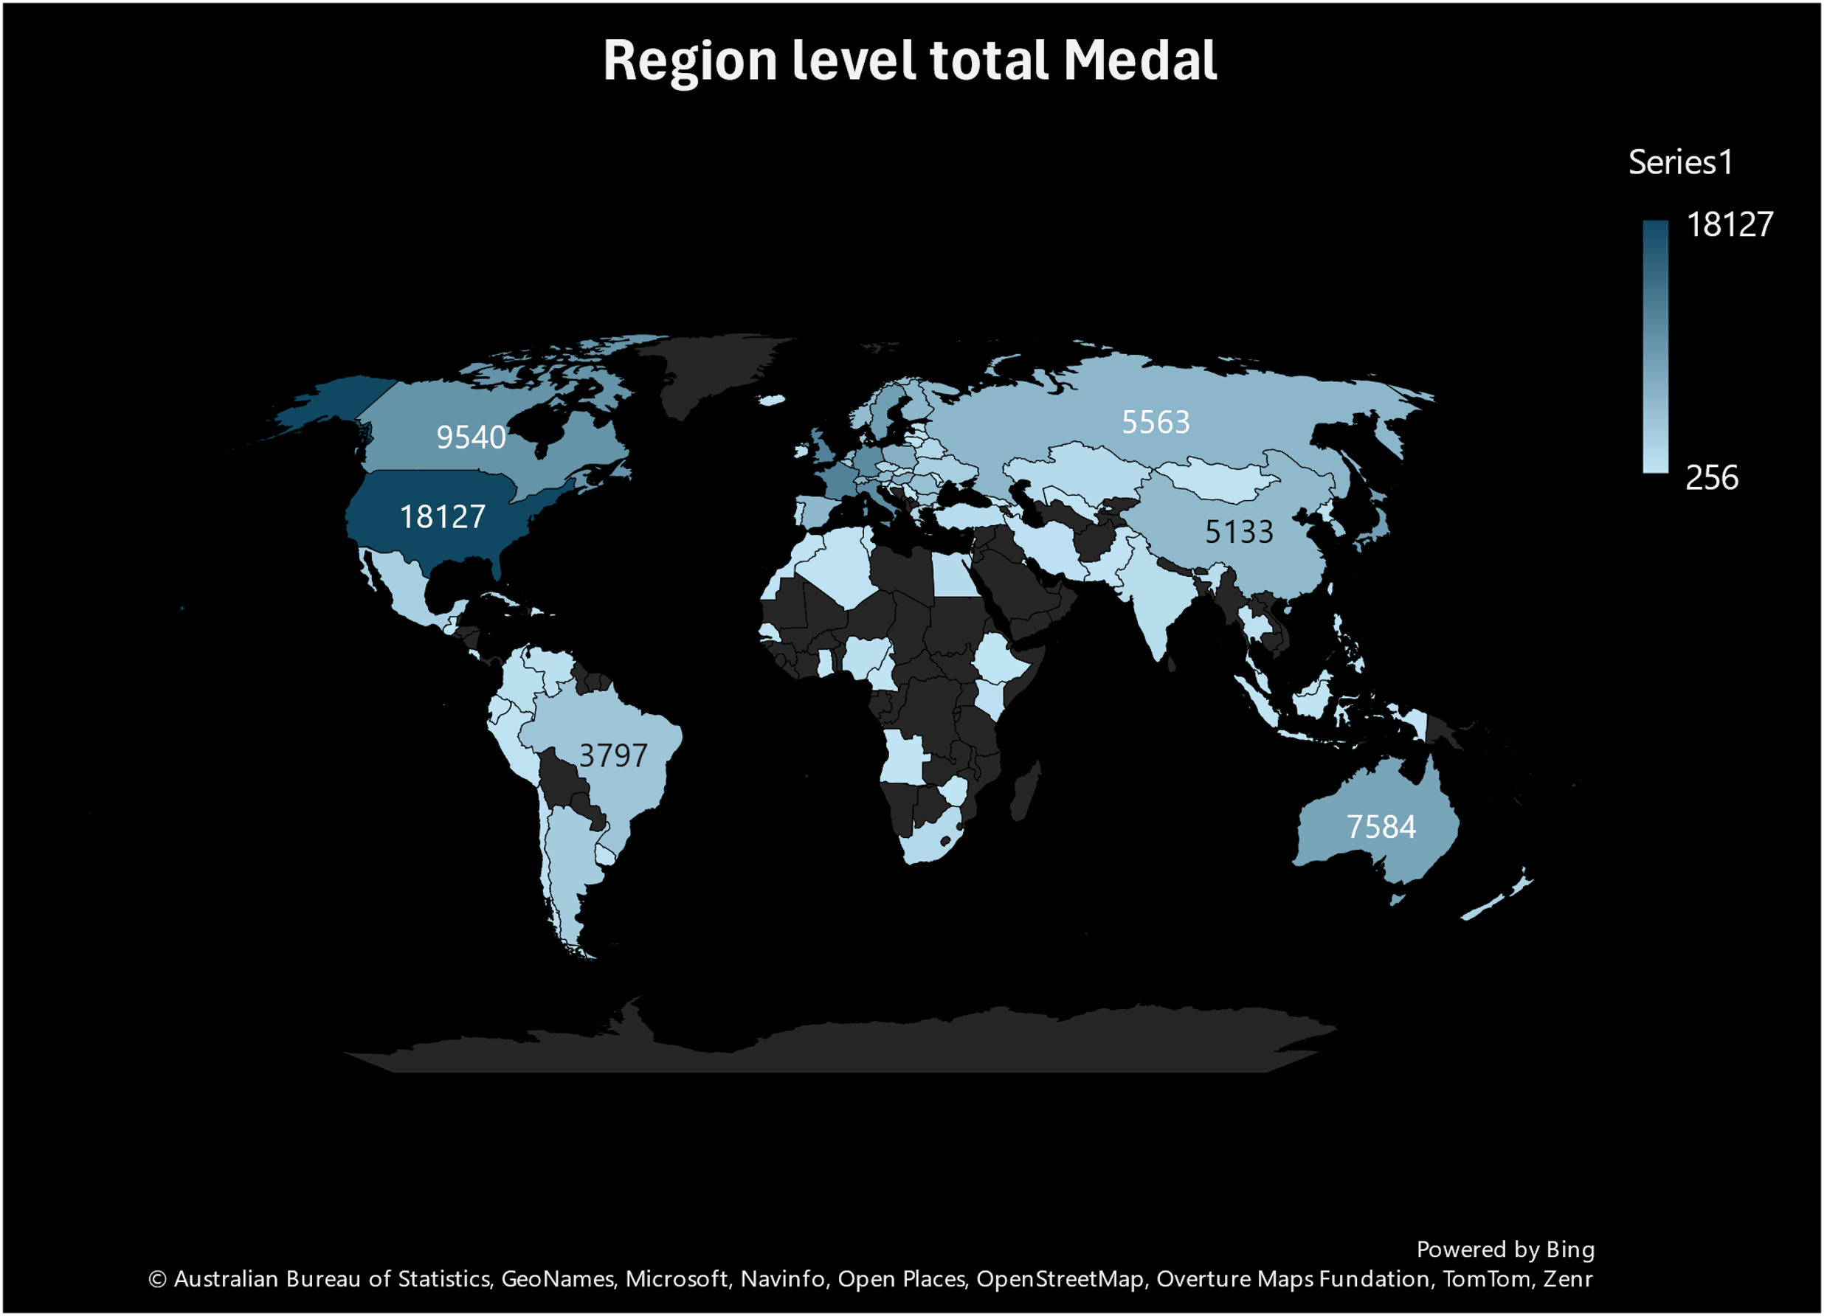

Regions like the USA, UK, France, Germany, and Italy have consistently made a significant impact on the overall Olympic medal tally, dominating across a wide range of sports and editions of the Games. Their sustained success can be attributed to a combination of factors, including robust sports infrastructure, substantial investment in athlete development, and a deep-rooted cultural emphasis on competitive sports. The USA, for instance, leads with its vast talent pool, advanced training facilities, and a highly competitive sports ecosystem, excelling in disciplines like swimming, athletics, and gymnastics. The UK’s success is driven by targeted funding, elite training programs, and a legacy of sporting excellence, particularly in cycling and rowing. Their contributions not only shape the competitive landscape of the Olympics but also set a benchmark for excellence, inspiring other countries to invest in sports development and strive for similar success on the global stage.

**Power BI Questions, Visualization and Conclusion.**

1. **How many Olympic Games have been held in each season (Summer vs. Winter)?**

As of 2020, a total of **29 Summer Olympic Games** and **23 Winter Olympic Games** have been held, reflecting the rich history and evolution of the Olympic movement since its modern inception in 1896. The Summer Olympics, held every four years (with exceptions during World Wars I and II), have grown significantly in scale and participation, featuring a wide range of sports and events that showcase athletic excellence on a global stage. The Winter Olympics, introduced in 1924, focus on cold-weather sports and have also expanded over time, with new disciplines and increased participation from countries around the world. The difference in the number of editions between the Summer and Winter Games is due to the later introduction of the Winter Olympics and the fact that they are held in alternating even-numbered years. This historical count underscores the Olympics’ enduring legacy as a platform for international unity, cultural exchange, and the celebration of human achievement in sports. The data highlights the global reach and significance of the Games, as well as their ability to adapt and grow over more than a century of competition**.**

1. **What is the distribution of games across different decades?  
     
   A graph with a line

   Description automatically generated**

The distribution of Olympic Games across decades reveals a fascinating pattern of growth, interruptions, and evolution in the history of the modern Olympics. The first Olympic Games of the modern era were held in the **1890s**, with a single edition in 1896, marking the revival of this ancient tradition. The **1900s** and **1920s** each saw four editions, reflecting the early establishment and growing popularity of the Games. However, the **1910s** and **1930s** experienced fewer editions, with only two Games each, due to the disruptions of World War I and the Great Depression. The **1940s** saw no Olympic Games at all, as World War II forced the cancellation of both the 1940 and 1944 editions. The Games resumed in the **1950s**, with two editions, and gradually regained momentum in the **1960s** and **1980s**, each decade hosting four Games. The **1990s** continued this trend with four editions, while the **2000s** and **2010s** marked a significant increase, with six Games each, reflecting the expansion of the Olympic program and the introduction of the Winter and Summer Games in alternating even-numbered years. As of 2022, the **2020s** have already hosted two editions, despite the challenges posed by the COVID-19 pandemic, which delayed the 2020 Tokyo Games to 2021. This distribution highlights the resilience and adaptability of the Olympic movement, as well as its ability to thrive despite global challenges, while also showcasing its growth into a truly global event with widespread participation and cultural significance.

1. **Which cities have hosted the most Olympic Games?The cities that have hosted the most   
   A screenshot of a computer screen

   Description automatically generated**Olympic Games are London, UK (1908, 1948, 2012), Paris, France (1900, 1924, 2024), and Los Angeles, USA (1932, 1984, 2028). Each of these cities has hosted the Games three times, reflecting their historical significance, robust infrastructure, and ability to organize large-scale international events. Their repeated selection as host cities underscores their enduring role in the Olympic movement.
2. **What is the distribution of sports between the Summer and Winter Olympics?  
   A graph of a number of different seasons

   Description automatically generated with medium confidence**

The Summer Olympics feature 33 sports, including Athletics, Swimming, and Gymnastics, while the Winter Olympics include 15 sports, such as Alpine Skiing, Ice Hockey, and Figure Skating. This distribution highlights the diversity of the Olympic program, with the Summer Games offering a broader range of disciplines due to their larger scale and global appeal.

1. **Which sports have the highest number of events in the Olympics?  
   A graph of sports events

   Description automatically generated**The sports with the highest number of events are Athletics (47 events), Swimming (37 events), and Gymnastics (18 events). These sports are central to the Olympics, offering a wide variety of disciplines that test different skills and attract significant global participation and viewership.
2. **How has the participation in each sport evolved over time?  
   A graph with a line

   Description automatically generated**Participation has increased significantly in popular sports like Swimming and Athletics, driven by their global appeal and accessibility. In contrast, niche sports like Modern Pentathlon have remained relatively stable, with limited growth due to their specialized nature. This trend reflects the evolving preferences and priorities of athletes and audiences over time**.**
3. **How many events are there in each sport?   
   A graph of different sports

   Description automatically generated**The number of events varies by sport, with Athletics leading at 47 events, followed by Swimming (37 events), Cycling (22 events), Gymnastics (18 events), and Rowing (14 events). This distribution showcases the diversity and complexity of the Olympic program, with each sport offering multiple opportunities for athletes to compete.
4. **What is the distribution of events by gender (Men, Women, Mixed)?  
   A screenshot of a graph

   Description automatically generated** The distribution of events by gender is 48% Men’s events, 45% Women’s events, and 7% Mixed events. While Men’s events still dominate, the increasing inclusion of Women’s and Mixed events reflects the Olympics’ commitment to gender equality and inclusivity.
5. **How has the number of events changed over time?  
   A bar code with numbers

   Description automatically generated with medium confidence**The number of events has grown significantly, from 43 events in 1896 to 339 events in 2020. This growth is particularly notable in Women’s and Mixed events, which have been added to promote gender equality and broaden the appeal of the Games.
6. **What is the distribution of participants by gender?  
   A purple and green pie chart

   Description automatically generated**The distribution of participants is 58% Male and 42% Female. While male participants still outnumber females, the gap has narrowed over time, reflecting efforts to promote gender equality in sports.
7. **Which countries have the highest number of participants in the Olympics?  
   A purple bar graph with white text

   Description automatically generated**The countries with the highest number of participants are the USA (10,000+), the UK (5,000+), and Germany (4,500+). These nations have consistently sent large delegations to the Games, reflecting their strong sports cultures and extensive athlete development programs.
8. How does the age distribution of participants vary across different games?  
   A graph of a number of participants

   Description automatically generated  
   The average age of participants varies by sport, with Gymnastics having the youngest athletes (20-25 years), Equestrian the oldest (35-40 years), and Swimming falling in between (22-27 years). This variation reflects the physical demands and skill requirements of different sports.
9. **How many medals have been awarded in each Olympics?   
   A graph with purple bars

   Description automatically generated**The number of medals awarded has increased over time, with 974 medals in 2016 Rio, 962 in 2012 London, and 958 in 2008 Beijing. This growth reflects the expansion of the Olympic program and the inclusion of more events and participants.
10. **Which countries have the highest number of gold medals?  
    A screenshot of a computer

    Description automatically generated**The countries with the highest number of gold medals are the USA (1,022), China (546), and Russia (521). These nations have consistently performed at the highest level, showcasing their dominance in a wide range of sports
11. .**How does the medal distribution vary across different sports?  
    A screenshot of a graph

    Description automatically generated**The medal distribution varies significantly by sport, with Athletics awarding the most medals (1,500+), followed by Swimming (1,200+) and Gymnastics (800+). These sports are central to the Olympics and offer numerous opportunities for athletes to achieve podium finishes.
12. **How many regions or NOCs participate in each Olympic Games?  
    A screenshot of a computer

    Description automatically generated**

The number of participating NOCs has grown over time, with 206 in 2020 Tokyo, 207 in 2016 Rio, and 204 in 2012 London. This growth reflects the increasing global reach and inclusivity of the Olympic movement.

1. **Which regions have the highest number of participants in the Olympics?  
   A graph of a number of countries/regions

   Description automatically generated**The regions with the highest number of participants are Europe (50,000+), North America (30,000+), and Asia (25,000+). These regions have historically dominated the Games, reflecting their strong sports cultures and extensive resources.
2. **What is the distribution of medals among different regions?  
   A blue and purple bars

   Description automatically generated with medium confidence**The distribution of medals is heavily skewed toward Europe (10,000+), followed by North America (6,000+) and Asia (4,000+). This reflects the historical dominance of these regions in Olympic competition, driven by their investment in sports development and athlete training.

**ER Diagram**

